Sean Begley
5/2/2006
Independent Study Report
Implementation of a Wavetracking Algorithm on ISAC
Spring 2006

Introduction

The goal of this project was to create a wave-tracking component IMA 2.5 that would allow ISAC (Intelligent Soft Arm Control) to sense an individual waving their hand in space, follow it, and then reach out to it. The basic algorithm would work as follows. ISAC would sense a waving hand and lock onto that hand. He would then follow it as it moved around the environment, and then, once it stopped moving for a time, release the hand from its vision and lock onto the point in space where the hand was. ISAC would then reach out with his right arm to that location, perhaps to initiate a handshake. This project represents an extension of the work that I, along with several other students, performed last semester. Unfortunately, the work last semester proved to be more then simply one semester worth of work and spilled over into a good portion of this semester’s time.

Overview of Last Semester’s Work

Last semester, Peter Humke, Jason Kientz, and I (Sean Begley) worked together to integrate the OpenCV library into the IMA system utilized by those working on ISAC, Vanderbilt’s humanoid robot. This was a capability that we, and Dr. Peters, deemed necessary as the OpenCV libraries contain a variety of functions that not only simplify the creation of solutions to Computer Vision problems, but also increase their performance by use of the Intel Performance Primitives. These Intel Performance Primitives are hardware level instructions that have been specially designed for use with Intel Processors. When last semester’s work came to a close we had, in front of us, a template, written in C++, that would allow a user to construct components for use in IMA 2.5, without much interaction with the IMA bindings themselves. Our template already included the necessary files to use the functionality provided by Intel’s OpenCV library. To demonstrate its functionality we built a simple background subtraction module that would visualize a scene and find the center of motion in that scene based on either a static or running average background subtraction. This involved interfacing our template with the left and right frame grabbers, which allowed us to interact with the cameras, providing our input image data.

Goals of This Semester’s Work

The goal of this semester’s project was to build upon what was done last semester. Last semester’s work enabled more complex goals to be achieved. This semester’s work represents one of those complex goals. This semester we intended to create a component, using what we had created last semester, to allow ISAC to track a moving hand. This is a capability that ISAC did not possess that Dr. Peters wanted to see implemented. The specific aim was to enable ISAC to recognize a waving hand, follow it to a location, and then, via some other signal, stop following the hand. A supplementary goal was to incorporate arm motion into the mix by having ISAC, if within his range of motion, reach out to the newly found point of interest. The work this semester can be split into two broad categories; wave tracking, and incorporation of arm motion.

Implementation of Wave Tracking

The expansion of last semesters work to sense a waving hand and then track the motion of that hand is primarily a Computer Vision problem. All of the other pieces, relating to ISAC and IMA, were already in place via the background subtraction demo that we put together. Peter Humke headed up this portion of the work, although we were both involved in all aspects of the project. This wave track algorithm builds on the theory of the background subtraction we used last semester. To implement this wavetracking we first used a simple background subtraction, like the one we created last semester, to get ISAC’s attention by waving your hand. The tracking portion of the algorithm is accomplished by continuously centering the camera on the region within the image which has the smallest difference between the original color histogram and the color histogram for the region of interest. Each time the histogram is compared we keep track of how much motion was present and if a n number of frames go by with little enough camera motion then we consider the tracking to be complete. This is when the arm motion is enabled to allow ISAC to move his right hand out to meet the point of interest.

Implementation of Arm Motion

I was in charge of integrating the arm into this project. That meant determining a method that would cause the arm to move out to where the eyes had focused after the wave tracking was complete. My initial thoughts revolved around what I had learned in EECE 254 Computer Vision and EECE 271 Intro to Robotics. In Computer Vision class I learned about calculating z-depth from a stereo pair of images. This seemed like a good starting point since the location of ISAC's “eyes” is fixed and this calculation can be performed.

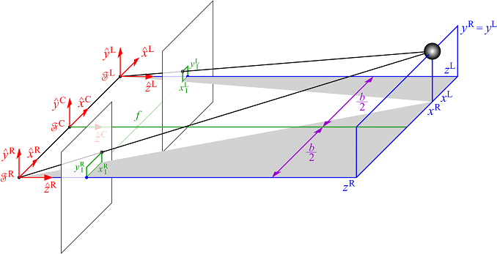
Figure 1: Depth from Disparity Diagram^{i}

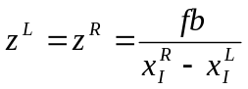
Equation 1: Depth from Disparity^{i}

Figure 1 shows a diagram of the basic setup necessary to calculate depth from disparity. Equation 1 shows the, rather simple math, involved in finding this depth if all of the necessary factors are known.
In Intro to Robotics I learned about forward and inverse kinematics, and transforming coordinates from one frame of reference to another. This would have been necessary since the coordinates I got from my z-depth calculation would have been in terms of the cameras and I would need to translate them to reference ISAC's arm. As I explored this option further I, once again, was shown the advantages of the IMA and its modular design.
ISAC's “eyes” are moved via precise pan title step motor units. These units are Directed Perception PAN-TILT UNIT’s model: PTU-46-17.5. The position of both the pan and tilt of these motors can be sampled at any time. From these positions angles off center can be calculated. From these angles and the knowledge of how far apart the cameras are from each other one can calculate the point in space where the two cameras’ principle axes converge.
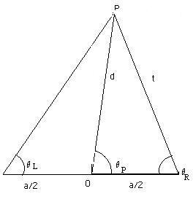
Figure 2: Top Down View, 3D Estimation^{ii}

Figure 2 shows a top down representation of ISAC looking at a point in space. We know a (the distance between ISAC’s eyes) and we know Θ_{L} & Θ_{R} (the pan angles of ISAC’s eyes). What we ultimately want to calculate is d, the depth of our point of interest. To do this we will need t however. t can be calculated using the Sine Law show in Equation 2.

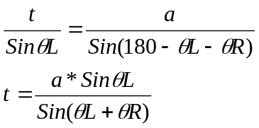
Equation 2: Sine Law^{ii}

Now that we have calculated t we have everything we need to estimate the depth of our point of interest. Equation 3 shows us how to calculate depth from what we know.

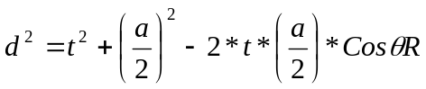
Equation 3: Cosine Law^{ii}

This, of course, only gives us a 2 dimensional representation of our point of interest. To realize a full 3 dimensional representation we will need to find the height of our object as well. The tilt angle of ISAC’s eye control units can be sample just like the pan angles. They will, generally speaking, have two slightly different tilt angles and so we can average the two to come up with a single tilt angle for use in calculations. Figure 3 shows a side view of our cameras and point of interest. We have d from our previous calculations and we have Φ_{tilt} from our sample of the pan tilt angles of our control unit.

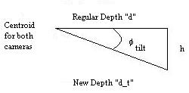
Figure 3: Side View, 3D Estimation^{ii}

We want to find h and d_t and we can do so using Equations 4 and 5. Equation 5 is, of course, Pythagorean’s Theorem.

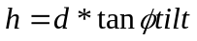
Equation 4¹

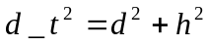
Equation 5: Pythagorean's Theorem^{ii}

Now we know the position of our point relative to ISAC’s eyes. To fully realize our goal of getting XYZ coordinates for our point of interest to be used by ISAC’s arm we must convert these into XYZ coordinates relative to ISAC’s space. Equations 6, 7, 8, and 9 give us these coordinates based on the values that we have just found.

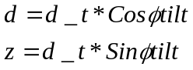
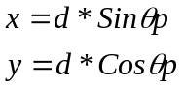
Equations 6, 7, 8, 9^{i}

The Head Component, which controls ISAC’s pan/tilt camera mounts, contains logic to perform the above calculations. One of its IMA bindings is labeled 3DOutput. This 3DOuput binding is continually fed an XYZ coordinate, calculated by DepthEstimator, relative to the portion of ISAC’s frame that represents the convergence point of the principle axes of his “eyes.” These XYZ coordinates are calculated using the above process.
The second step in the process is to come up with a trajectory by calculating joint angles, via inverse kinematics, that allow the end effector to converge on the XYZ coordinates found by the Head Component. The arm then, of course, has to follow this trajectory to actually realize the goal. The trajectory can be generated by the TrajectoryGen component from the TrajectoyLib. This component essentially takes in a start location and end goal, along with a desired number of steps, and generates a trajectory that can be used by the arm controller to realize motion. In this project only the right arm is involved although the process would be virtually identical if the left arm, or even both arms, were used.
Lets assume, for the purposes of this paper, that the newly created trajectory is a straight line trajectory with a start location, end goal, and no viapoints in between. The end goal feeds into an IMA binding in the arm controller known as the, aptly named, DesiredXYZPosition. Whenever the arm controller receives a new DesiredXYZPosition it attempts to move its end effector, a hand in this case, to that point. The arm controller, of course, has mechanisms in place to ignore points outside if its range of motion to keep from damaging itself.

Combining the Two

What has just been described is the methodology and part of the mathematical process to go from two cameras looking at a point to an arm reaching out to that point. The modularity of IMA means that a lot of functionality doesn’t have to be recreated every time a new capability is to be put in place. I will now go on to describe the process one must go through to actually integrate the wave tracking capabilities with the arm motion components in ISAC’s IMA 2.5 environment.
This process involves using IMA2_DAD.exe (Distributed Agent Designer 1.0) to link together, and modify, some IMA components that others have already created along with our own Wavetracker component built on the OpenCV template that we developed last semester. I’ve created a new agent called WT_WTComplete, which is an adaptation of the RightReachDemo created by Juan Rojas. This agent contains a RightArm, RightTrajectoryAgent, and Wavetracker component. The Wavetracker component is an adaptation of the background subtraction component that we built last semester. Figures 4 and 5 show the state machines that I created to operate the individual Wavetracker component, and the entire Wavetracking system, from within IMA2_DAD.

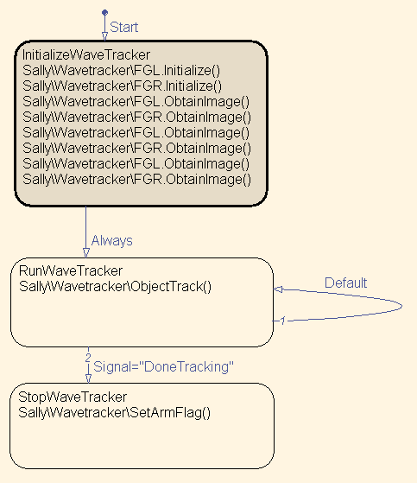
Figure 4: Wavetracker State Machine

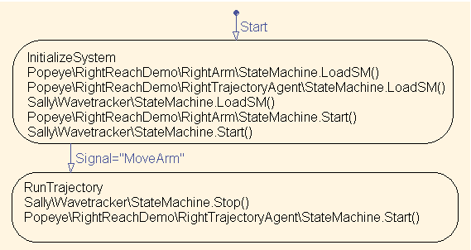
Figure 5: WT_WTComplete State Machine

The Wavetracker state machine initializes the Framegrabbers that we use and then starts the ObjectTracking. ObjectTracking is continually called until the logic senses that the tracked object is no longer moving and the DoneTracking flag is set. At this time the Wavetracker state machine moves into a stop state.
The WT_WTComplete state machine is designed to run the entire system. It arbitrates the 3 other state machines in the system: WT_WavetrackerAgent, WT_RightArmAgent, and WT_RightTrajectoryAgent. The WT_WTComplete state machine loads up the other 3 state machines and then starts the RightArm and Wavetracker machines. When it receives the signal to move the arm, analogous to the Wavetracker having completed its tracking, it starts the RightTrajectory machine which takes over copying the 3dOutput from the HeadAgent, creating a trajectory, and then feeding that trajectory to the DesiredXYZPosition of the RightArm.
To actually put all of these components together one must log onto Sally and Popeye under the same user name. Open IMA2_DAD.exe on both machines and then, on only 1 machine, goto Tools >> Connect, click the Use Preset checkbox and choose Head and Right Arm. Once this is done add the OpenCV_WTComplete component to Popeye and the OpenCV_Wavetracker component to Sally. To actually activate the process all that is necessary is to run the WT_WTComplete state machine. Keep in mind that the air supply system must be up and running for the arm to work.

Results and Discussion

Our implementation, as of 5/2/2006 is not in a complete working state. During integration testing we were plagued with some very difficult errors revolving around our component not being registered properly and IMA2_DAD.exe crashing when we tried to load up a component that used the OpenCV libs. This is not, however, a total loss. Peter has written all of the code for the actual wavetracking algorithm and I have built the necessary components and state machines to run the system. The theory behind the arm being moved to an XYZ coordinate has been successfully tested and once the crashes in IMA2_DAD.exe can be resolved there should be little more then some logical debugging to go through before the entire wavetracking system is fully operational. As an independent study, this experience has given Peter and me a great learning opportunity. The ISAC lab has given us the chance to work on a large scale, multi-user system that is absolutely unavailable in the classroom. Even though we could not get our component functioning in the time frame we were allotted, I am confident that given a little more time we would be able to generate a solution to the need for a wavetracking capability. This project, of course, would be an excellent starting point for future projects. Our template scheme should reduce the learning curve associated with IMA 2.5 and allow others to jump into new and preexisting projects more quickly then ever before. This semester’s work represents a more complex use of the template and has brought with it more complex problems to overcome. My work these past several months has given me great hands on experience with ISAC and, more generally, complex robotic systems. My work the past 3 semesters with ISAC has given me invaluable insight and knowledge with regard to my future studies, which will revolve around Robotics at Graduate School at Vanderbilt University.

Conclusion

This semester Peter and I set out to expand on our work from last semester. Last semester we worked to create a template that would allow future users to quickly and easily integrate Intel OpenCV functionality into their IMA 2.5 components without having to know as much about the finer points of IMA as previous generations. Last semester we demonstrated what we had created with a fairly simple background subtraction implementation. This semester’s work represented a more intricate project that still utilized our template and the OpenCV library. We expanded it further by integrating other parts ISAC into the equation, namely his arms. We’ve learned a great deal and this should provide future users with an example of a complex design built on the framework we hope they will use. Our work has created a base for future projects to build from and is very assessable. One such future project would be to finish implementing what we’ve started with the wavetracking system. The code and logic is all there but there are some bugs that need to be worked out before it can be considered “production ready.” Other future projects could span the gambit in terms of ISAC’s functionality. Our template was designed to be flexible and should allow users the opportunity to do almost anything with the OpenCV library. It is my hope that students use our work in the future and that it helps advance the work being done with ISAC.

References

Vanderbilt Intelligent Robotics Lab Intranet. Eds. Anthony Alford & Mark Cambron. May 3rd 2006. <\\cis\common\InetPub\wwwroot\IRL\default.htm>

“Depth Estimation Paper”. Vanderbilt Intelligent Robotics Lab Intranet. July 11th 2003. Vanderbilt University. May 3rd 2006 <\\cis\common\InetPub\wwwroot\IRL\Doc\Components\Depth Estimation Paper.doc>.

“Traj Play and Gen Comp”. Vanderbilt Intelligent Robotics Lab Intranet. Vanderbilt University. May 3rd 2006
<\\cis\common\InetPub\wwwroot\IRL\Doc\Components\Traj Play and Gen Comp.doc>

“How To Control Isac’s Arm”. Vanderbilt Intelligent Robotics Lab Intranet. Vanderbilt University. May 3rd 2006
<\\cis\common\InetPub\wwwroot\IRL\Doc\Softarm\How To Control Isac's Arm.doc>

“Lecture Notes: Stereopsis (Coplanar)”. EECE 254 Computer Vision. Richard Alan Peters II. Vanderbilt University. Spring 2005.

Figures and Equations from Richard Alan Peters Computer Vision lectures Spring 2005 ^{ii} Figures and Equations from the Depth Estimation Paper

